***Manipulating and Changing Styles of HTML Elements with JavaScript***

Change properties using JS instead of CSS.

<https://www.w3schools.com/jsref/dom_obj_style.asp>

In JS properties are changes in strings but in CSS we only change values

Like:

**In CSS**

h1{

color:red;

}

**In JS**

document.querySelector("h1").style.color = "red"; //red is written in strings.

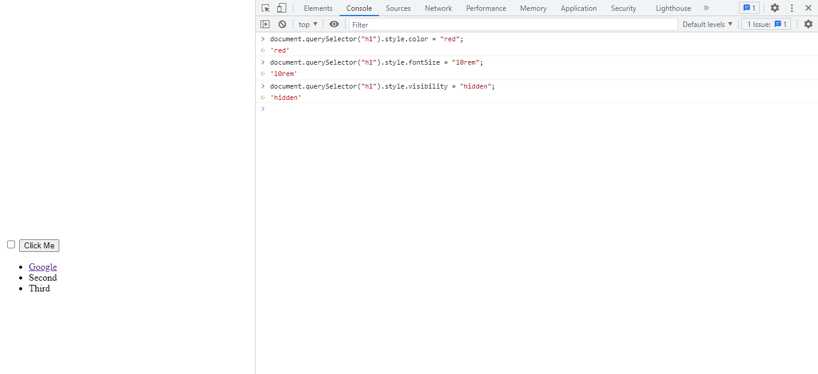

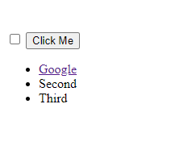

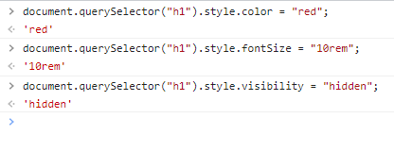

Let’s change button background color.

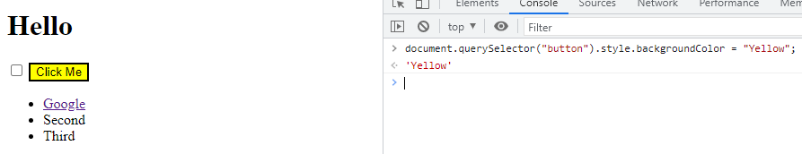

<https://www.w3schools.com/jsref/prop_style_backgroundcolor.asp>